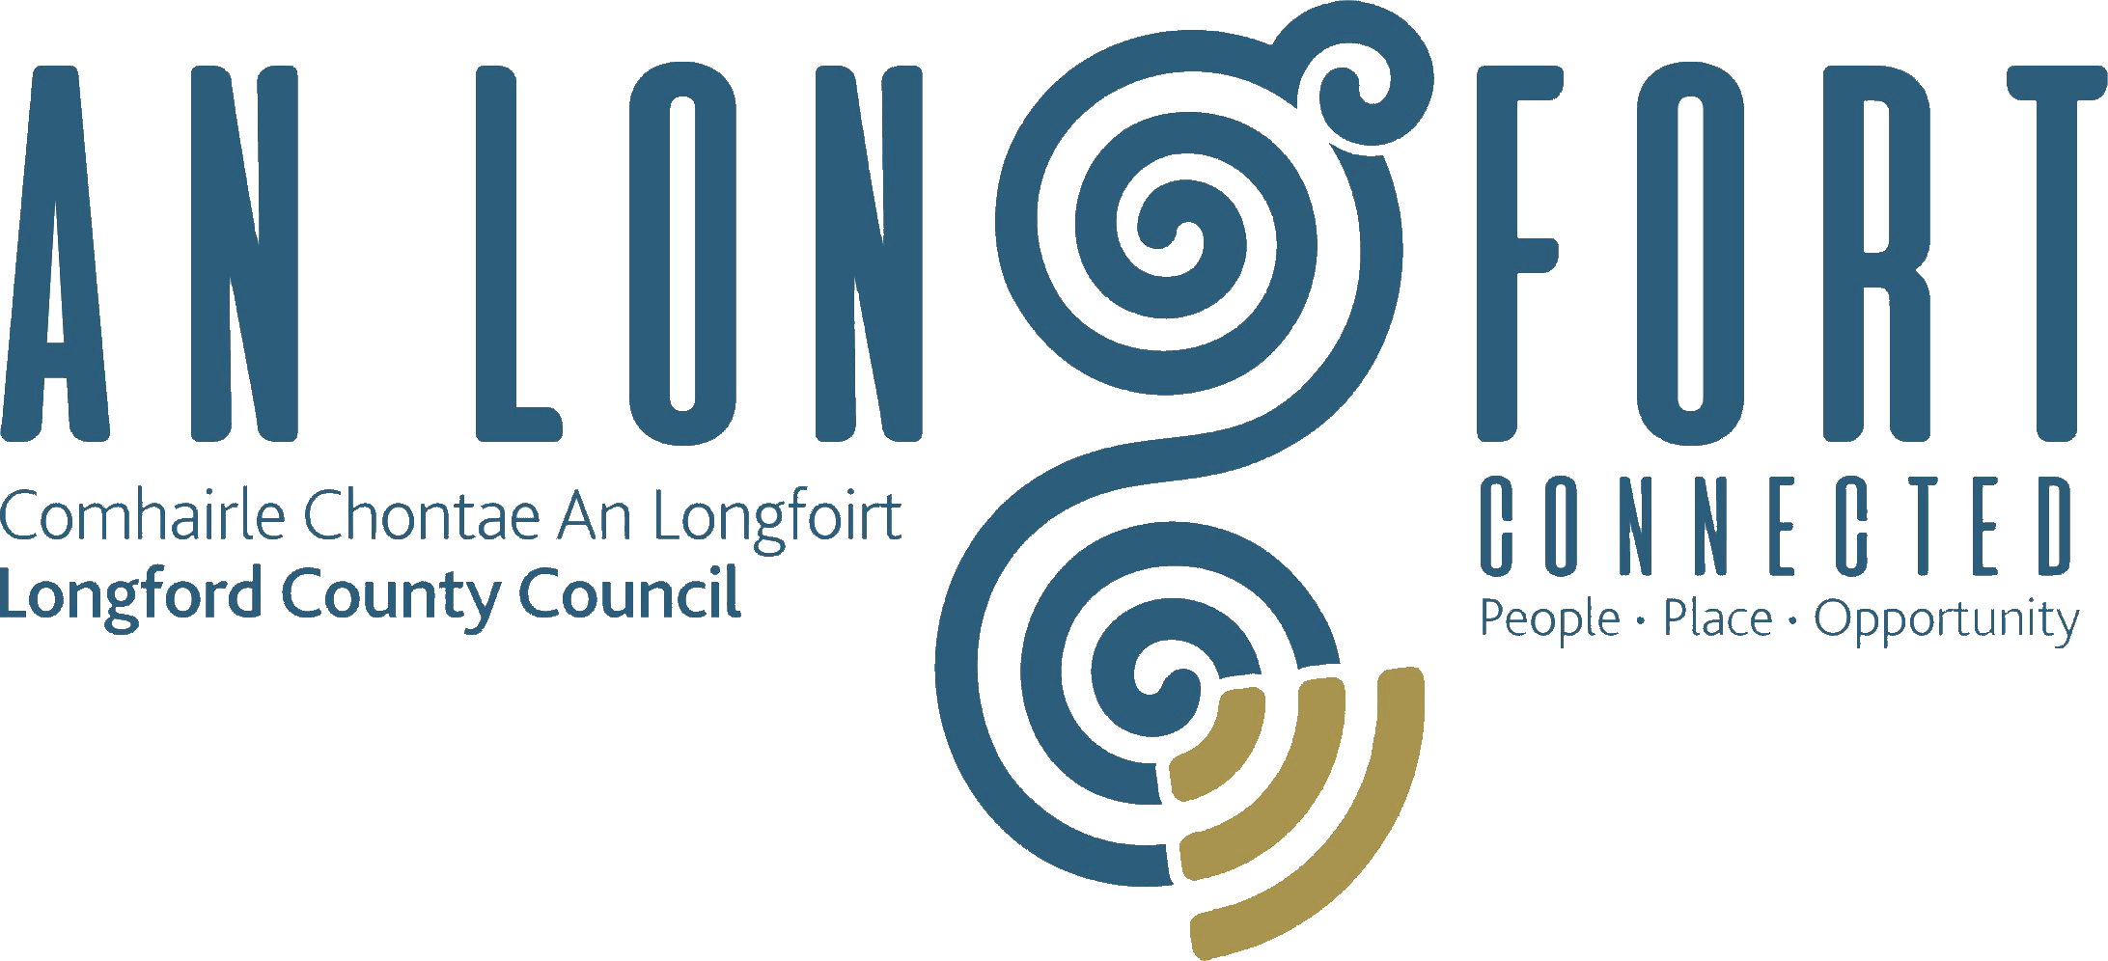

Minutes of Joint Policing Committee Meeting held in the Council Chamber,
Aras an Chontae, Great Water Street, Longford on
Monday, 5th March 2018 at 3.00 p.m.

PRESIDING: Councillor Gerry Warnock.

PRESENT: Councillors - Paraic Brady, Mick Cahill, Joe Flaherty, Colm Murray, John Browne, Seamus Butler,
Peggy Nolan, Pat O’Toole, P.J. Reilly and Paul Ross.
Ms. Madeline Bennett, Ms. Emma Kiernan,
Ms. Rosalind Greene
Superintendent Jim Delaney.
Superintendent Brian Mohan.
Inspector Blaithin Moran.

Mr. Paddy Mahon, Chief Executive.
Ms. Barbara Heslin, Director of Services.
Mr. Ciaran Murphy, Senior Executive Officer.

APOLOGIES:- Councillors - Gerard Farrell, Martin Mulleady,
Mr. Peter Cox and Mr. Luke Casey,

MEETINGS
ADMINISTRATOR: Anne Lee.

WELCOME.

Councillor Warnock welcomed Councillor Joe Flaherty, who is replacing former Councillor Padraig Loughrey, and Emma Kiernan who is replacing Aisling Nolan on the Committee.

ADOPTION OF MINUTES.

On the proposal of Councillor P. Nolan seconded by Councillor P. O’Toole, it was unanimously agreed to adopt minutes of Joint Policing Committee meeting held on the 4th December 2017, as circulated.
MATTERS ARISING.

None.

GARDA REPORT.

Superintendent Delaney briefed the members on the following and replied to queries raised –

- Statistics -
  - Burglaries/Thefts.
  - Public Order offences.
  - Victim Based Crime.
  - Robberies with violence.
  - Roads Policing.
  - Drink/Drug Driving Offences.
  - AXA Roadshow for School Children.

Supt. Delaney referred to a number of upcoming events at which a Garda presence will be required and informed the members that there will be a need to charge for Garda presence at such events.

Superintendent Mohan briefed the members on the following and replied to queries raised –

- Assaults.
- Fatal Accident.
- Drink/Driving convictions.
- Thefts/Burglaries.
- Supply and Sale of Drugs and identification of Grow Houses - Supt. Mohan encouraged the public to notify the Gardai immediately if they are suspicious of any persons/premises in their areas.
- Fatal Fire in the Granard area.
- Upcoming events in the Granard area.

Supt. Mohan commended the efforts of his former colleagues following the arrest of a man for the murder of Detective Garda Adrian Donohoe in Dundalk in 2013.

Supts. Delaney and Mohan requested the Committee’s support regarding funding for renovation project at Longford Station and also the upgrading of the Garda Barracks in Ballymahon and Granard.

Councillor P. Nolan proposed and Councillor C. Murray seconded that the Minister for Justice and Equality be requested to receive a deputation from the Joint Policing Committee regarding resources for the Garda Authorities in County Longford.

Supts. Delaney and Mohan, the Cathaoirleach, members and Chief Executive thanked and complimented the many groups and individuals whose efforts over the severe weather ensured that the effects of the severe weather event were kept to a minimum.

LOCAL AUTHORITY REPORT.

Mr. C. Murphy, Senior Executive Officer, updated the members on the following and replied to queries raised -

- Funding Programmes.
- Regeneration Programme – including the Pedestrian Bridge over the River Camlin at the rear of the Council offices.
- Innovation Hub in the Providers Building, Longford town.
- Northern Quarter and Connolly Barracks.

UPDATE ON CCTV.
Supt. Delaney referred to the Garda Vetting process for the provision of CCTV and stated that it is anticipated that the Memorandum of Understanding will be finalised shortly.

LONGFORD JOINT ACTION PLAN.

P. Mahon gave an update under the following headings -

- Public Lighting.
- CCTV.
- Litter and dumping issues.
- Derelict Houses.
- Public Realm.
- Animal Welfare.

Supt. Delaney referred to the policing aspect of the Plan and replied to queries raised by Councillor John Browne regarding fears linked to intimidation in the area.

2017 ANNUAL REPORT.

On the proposal of Councillor C. Murray seconded by Councillor P. Brady, it was agreed to adopt the 2017 JPC Annual Report, as circulated.
A.O.B.

Scrap Metal.

Councillor P. Brady spoke regarding the sale of scrap metal following from burglaries in houses and emphasised the need for traceability of all scrap metal for sale.

Older Persons Council.

It was agreed that Sergeant Mullally and the Chairperson of the Older Persons Council address the members of Longford County Council regarding the work of the Council

DATE OF NEXT MEETING

It was agreed that the next meeting be held on the 11th June 2018.

This concluded the business of the meeting.
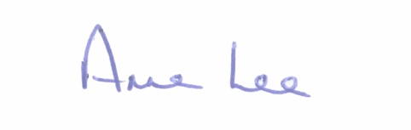

Signed: _______________
Anne Lee,
Meetings Administrator.

Confirmed and adopted at Joint Policing Committee Meeting held on the
11th June 2018.

Signed: __________________
Chairperson.

